Conten-based filtering

# Video : Colaborative filtering vs content-based filtering

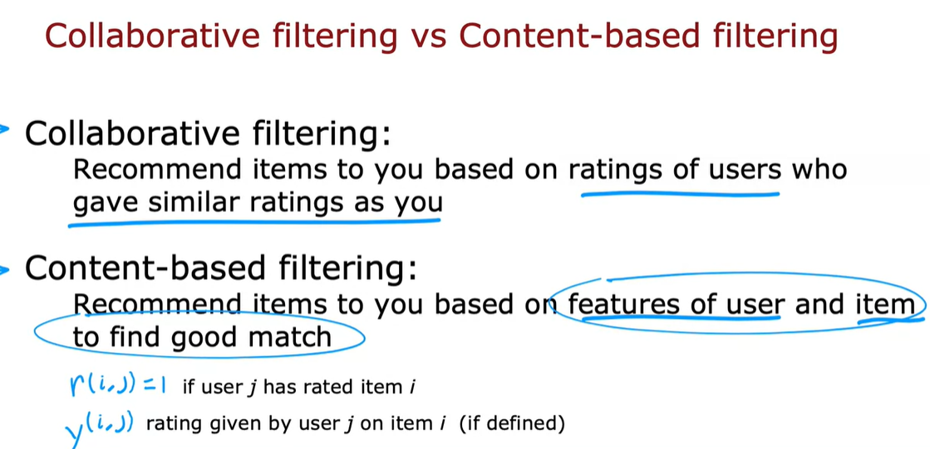

In this video, we'll start to develop a second type of

recommender system called

a content-based filtering algorithm.

To get started, let's compare and contrast

the collaborative filtering approach that we'll be

looking at so far with

this new content-based filtering approach.

Let's take a look.

With collaborative filtering,

the general approach is that we would recommend items to

you based on ratings of

users who gave similar ratings as you.

We have some number of users

give some ratings for some items,

and the algorithm figures out how to use

that to recommend new items to you.

In contrast, content-based filtering takes

a different approach to

deciding what to recommend to you.

A content-based filtering algorithm

will recommend items to you based on

the features of users and

features of the items to find a good match.

In other words, it

requires having some features of each user,

as well as some features of

each item and it uses those features to try to

decide which items and

users might be a good match for each other.

With a content-based filtering algorithm,

you still have data where users have rated some items.

Well, content-based filtering

will continue to use r, i,

j to denote whether or not user j has

rated item i and will continue to use y i,

j to denote the rating

that user j is given item i if it's defined.

But the key to

content-based filtering is that

we will be able to make good use of

features of the user and of the items to

find better matches than

potentially a pure collaborative

filtering approach might be able to.

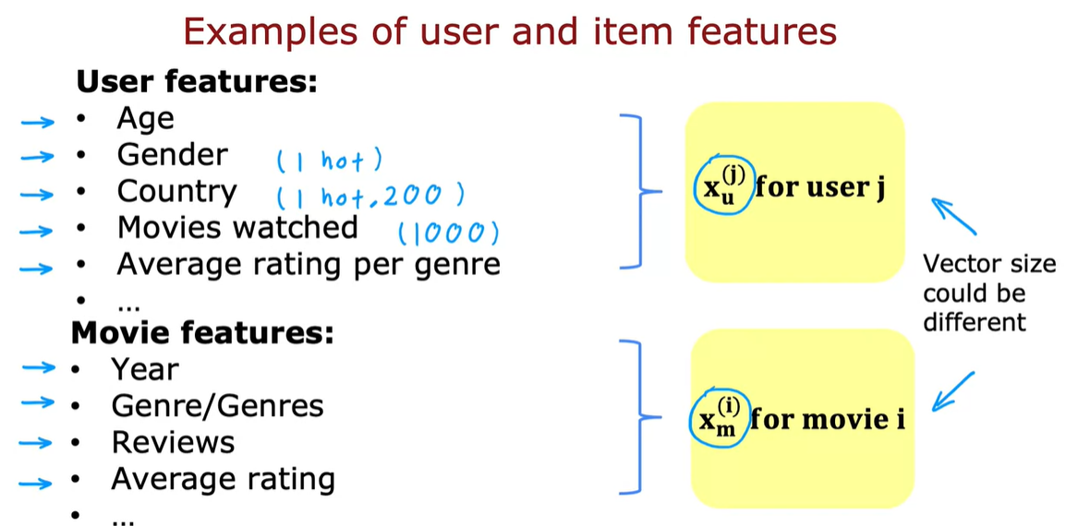

Let's take a look at how this works.

In the case of movie recommendations,

here are some examples of features.

You may know the age of the user,

or you may have the gender of the user.

This could be a one-hot feature

similar to what you saw when we were talking

about decision trees where you

could have a one-hot feature with

the values based on whether

the user's self-identified gender

is male or female or unknown,

and you may know the country of the user.

If there are about 200 countries

in the world then also be

a one-hot feature with about 200 possible values.

You can also look at past behaviors of

the user to construct this feature vector.

For example, if you look at

the top thousand movies in your catalog,

you might construct a thousand features that tells you of

the thousand most popular movies in

the world which of these has the user watch.

In fact, you can also take ratings the user might

have already given in order to construct new features.

It turns out that if you have a set of movies

and if you know what genre each movie is in,

then the average rating

per genre that the user has given.

Of all the romance movies that the user has rated,

what was the average rating?

Of all the action movies that the user has rated,

what was the average rating?

And so on for all the other genres.

This too can be a powerful feature to describe the user.

One interesting thing about this feature is that it

actually depends on the ratings that the user had given.

But there's nothing wrong with that.

Constructing a feature vector that

depends on the user's ratings is

a completely fine way to

develop a feature vector to describe that user.

With features like these you can then come up

with a feature vector x subscript u,

use as a user superscript j for user j.

Similarly, you can also come up with a set of

features for each movie of each item,

such as what was the year of the movie?

What's the genre or genres of the movie of known?

If there are critic reviews of the movie,

you can construct one or multiple features to

capture something about what

the critics are saying about the movie.

Or once again, you can actually take

user ratings of the movie to construct a feature of,

say, the average rating of this movie.

This feature again depends on the ratings

that users are given but again,

does nothing wrong with that.

You can construct a feature for

a given movie that

depends on the ratings that movie had received,

such as the average rating of the movie.

Or if you wish, you can also have

average rating per country or

average rating per user demographic as they

want to construct other types of

features of the movies as well.

With this, for each movie,

you can then construct a feature vector,

which I'm going to denote x subscript m,

m stands for movie,

and superscript i for movie i.

Given features like this,

the task is to try to figure out whether

a given movie i is going to be good match for user j.

Notice that the user features and

movie features can be very different in size.

For example, maybe the user features could be

1500 numbers and the movie features

could be just 50 numbers.

That's okay too.

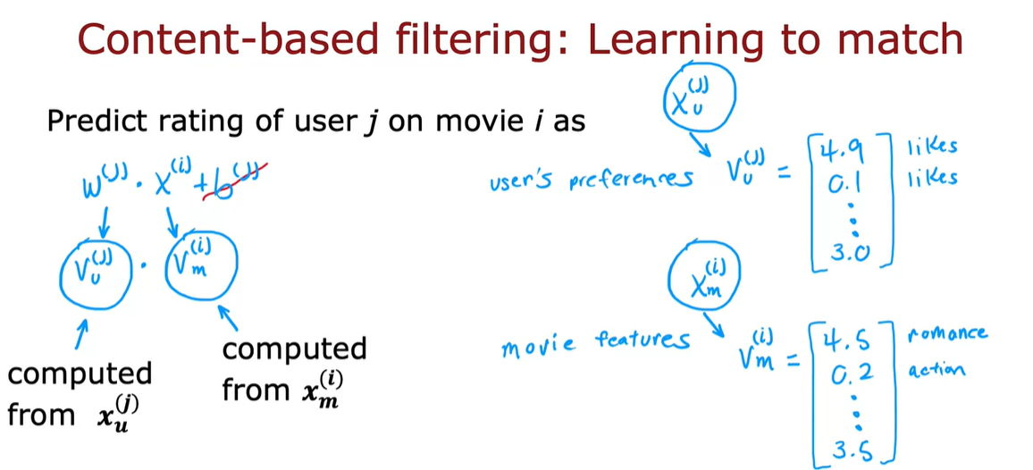

In content-based filtering,

we're going to develop an algorithm that learns to

match users and movies.

Previously, we were predicting

the rating of user j on movie

i as wj dot products of xi plus bj.

In order to develop content-based filtering,

I'm going to get rid of bj.

It turns out this won't hurt

the performance of the content-based filtering at all.

Instead of writing wj for a user j and xi for a movie i,

I'm instead going to just

replace this notation with vj_u.

This v here stands for a vector.

There'll be a list of numbers computed for

user j and the u subscript here stands for user.

Instead of xi,

I'm going to compute a separate vector subscript m,

to stand for the movie and

for movie is what a superscript stands for.

Vj_u as a vector as a list of numbers

computed from the features of user j

and vi_m is a list of numbers computed from

the features like the ones you saw on

the previous slide of movie i.

If we're able to come up with

an appropriate choice of these vectors,

vj_u and vi_m,

then hopefully the dot product

between these two vectors will be

a good prediction of

the rating that user j gives movie i.

Just illustrate what a learning algorithm

could come up with.

If v, u, that is a user vector,

turns out to capture the user's preferences,

say is 4.9,

0.1, and so on.

Lists of numbers like that.

The first number captures

how much do they like romance movies.

Then the second number captures how much do they

like action movies and so on.

Then v_m, the movie vector is 4.5, 0.2,

and so on and so forth of these numbers

capturing how much is this a romance movie,

how much is this an action movie, and so on.

Then the dot product,

which multiplies these lists of

numbers element-wise and then takes a sum,

hopefully, will give a sense of how much

this particular user will like this particular movie.

The challenges given features of a user, say xj_u,

how can we compute this vector vj_u that

represents succinctly or

compactly the user's preferences?

Similarly given features of a movie,

how can we compute vi_m?

Notice that whereas x_u

and x_m could be different in size,

one could be very long lists of numbers,

one could be much shorter list,

v here have to be the same size.

Because if you want to take

a dot product between v_u and v_m,

then both of them have to

have the same dimensions such as

maybe both of these are say 32 numbers.

To summarize, in collaborative filtering,

we had number of users give ratings of different items.

In contrast, in content-based filtering,

we have features of users and features of items and we

want to find a way to find

good matches between the users and the items.

The way we're going to do so is to compute these vectors,

v_u for the users and v_m for the items over the movies,

and then take dot products between

them to try to find good matches.

How do we compute the v_u and v_m?

# Video: Deep learning for content-based filtering

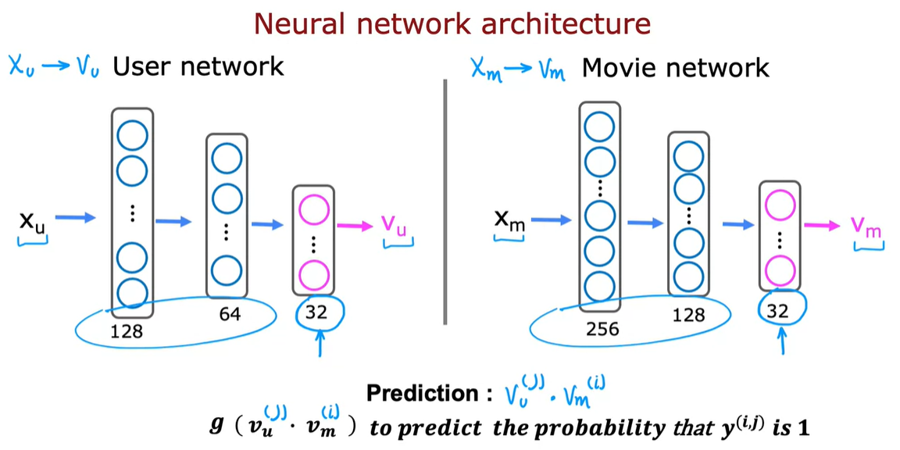

A good way to develop

a content-based filtering algorithm

is to use deep learning.

The approach you see in this video is the way that

many important commercial

state-of-the-art content-based filtering algorithms

are built today. Let's take a look.

Recall that in our approach,

given a feature vector describing a user,

such as age and gender, and country,

and so on, we have to compute

the vector v_u, and similarly,

given a vector describing

a movie such as year of release,

the stars in the movie, and so on,

we have to compute a vector v_m.

In order to do the former,

we're going to use a neural network.

The first neural network will

be what we'll call the user network.

Here's an example of user network,

that takes as input the list

of features of the user, x_u,

so the age, the gender,

the country of the user, and so on.

Then using a few layers,

say dense neural network layers,

it will output this vector v_u that describes the user.

Notice that in this neural network,

the output layer has 32 units,

and so v_u is actually a list of 32 numbers.

Unlike most of the neural networks

that we were using earlier,

the final layer is not a layer with one unit,

it's a layer with 32 units.

Similarly, to compute v_m for a movie,

we can have a movie network as follows,

that takes as input features of the movie and

through a few layers of

a neural network is outputting v_m,

that vector that describes the movie.

Finally, we'll predict the rating of this user on

that movie as v_ u dot product with v_m.

Notice that the user network and the movie network can

hypothetically have different numbers of

hidden layers and different numbers

of units per hidden layer.

All the output layer needs to

have the same size of the same dimension.

In the description you've seen so far,

we were predicting the 1-5 or 0-5 star movie rating.

If we had binary labels,

if y was to the user like or favor an item,

then you can also modify this algorithm to output.

Instead of v_u.v_m,

you can apply the sigmoid function

to that and use this to

predict the probability that's y^i,j is 1.

To flesh out this notation,

we can also add superscripts i and

j here if we want to emphasize that

this is the prediction by user j on movie

i. I've drawn here the user network

and the movie network as two separate neural networks.

But it turns out that we can actually

draw them together in

a single diagram as if it was a single neural network.

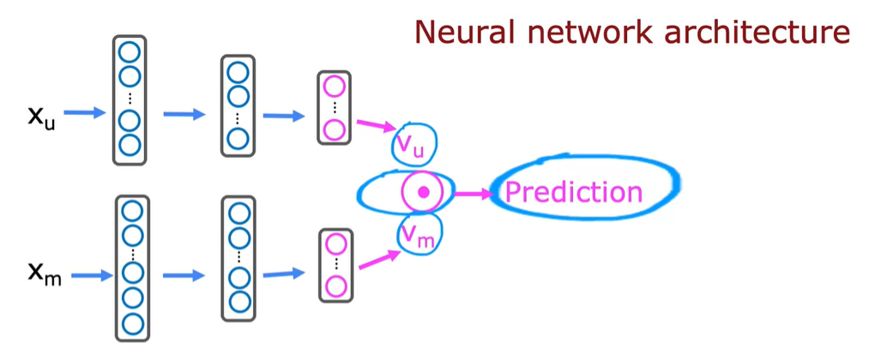

But it turns out that we can actually

draw them together in

a single diagram as if it was a single neural network.

This is what it looks like.

On the upper portion of this diagram,

we have the user network which

inputs x_u and ends up computing v_u.

On the lower portion of this diagram,

we have what was the movie network,

the input is x_m and ends up computing v_m,

and these two vectors are then dot-product together.

This dot here represents dot product,

and this gives us our prediction.

Now, this model has a lot of parameters.

Each of these layers of a neural network has

a usual set of parameters of the neural network.

How do you train all the parameters of

both the user network and the movie network

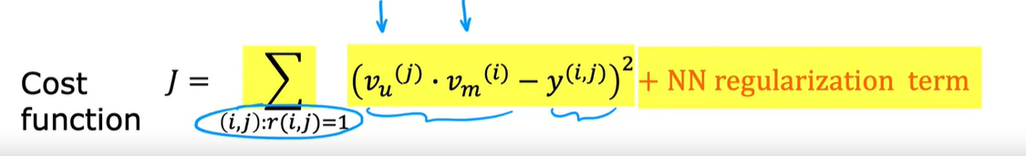

What we're going to do is construct a cost function J,

which is going to be very similar to

the cost function that you

saw in collaborative filtering,

which is assuming that you do have

some data of some users having rated some movies,

we're going to sum over all pairs i and

j of where you have labels,

where i,j equals 1

of the difference between the prediction.

That would be v_u^j dot product with

v_m^i minus y^ij squared.

The way we would train this model

is depending on the parameters of the neural network,

you end up with different vectors

here for the users and for the movies.

What we'd like to do is train the parameters

of the neural network so that you end up with

vectors for the users and for the movies that results in

small squared error into predictions you get out here.

To be clear, there's

no separate training procedure

for the user and movie networks.

This expression down here,

this is the cost function used to train

all the parameters of the user and the movie networks.

We're going to judge the two networks according to how

well v_u and v_m predict y^ij,

and with this cost function,

we're going to use gradient descent or

some other optimization algorithm to tune

the parameters of the neural network to cause

the cost function J to be as small as possible.

If you want to regularize this model,

we can also add the usual neural

network regularization term to

encourage the neural networks to keep

the values of their parameters small.

It turns out, after you've trained this model,

you can also use this to find similar items.

This is akin to what we have seen

with collaborative filtering features,

helping you find similar items

as well.

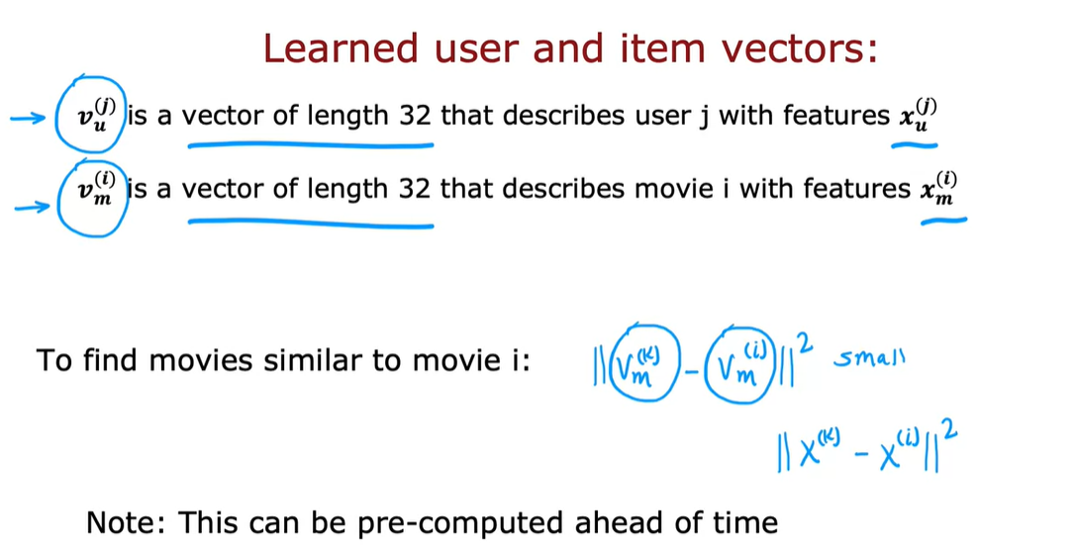

Let's take a look.

V_u^j is a vector of length 32 that describes

a user j that have features x_ u^j.

Similarly, v^i_m is a vector

of length 32 that describes

a movie with these features over here.

Given a specific movie,

what if you want to find other movies similar to it?

Well, this vector v^i_m describes the movie i.

If you want to find other movies similar to it,

you can then look for other movies k so that the distance

between the vector describing

movie k and the vector describing movie i,

that the squared distance is small.

This expression plays a role similar to what

we had previously with collaborative filtering,

where we talked about finding a movie with features

x^k that was similar to the features x^i.

Thus, with this approach,

you can also find items similar to a given item.

One final note, this can be pre-computed ahead of time.

By that I mean,

you can run a compute server overnight to

go through the list of

all your movies and for every movie,

find similar movies to it, so that tomorrow,

if a user comes to the website and

they're browsing a specific movie,

you can already have pre-computed to

10 or 20 most similar movies

to show to the user at that time.

The fact that you can pre-compute ahead of

time what's similar to a given movie,

will turn out to be important

later when we talk about scaling

up this approach to a very large catalog of movies.

That's how you can use deep learning to build

a content-based filtering algorithm.

You might remember when we

were talking about decision trees

and the pros and cons of

decision trees versus neural networks.

I mentioned that one of the benefits of

neural networks is that it's easier to take

multiple neural networks and

put them together to make them

work in console to build a larger system.

What you just saw was actually an example of that,

where we could take a user network and

the movie network and put them together,

and then take the inner product of the outputs.

This ability to put

two neural networks together this how we've

managed to come up with

a more complex architecture

that turns out to be quite powerful.

One notes, if you're

implementing these algorithms in practice,

I find that developers often

end up spending a lot of time carefully

designing the features needed to feed

into these content-based filtering algorithms.

If we end up building one of these systems commercially,

it may be worth spending some time

engineering good features for this application as well.

In terms of these applications,

one limitation that the algorithm

as we've described it is it can be

computationally very expensive to run if you have

a large catalog of a lot of

different movies you may want to recommend.

In the next video, let's take a look at some of

the practical issues and how you can modify

this algorithm to make a scale that are working

on even very large item catalogs.

Let's go see that in the next video.

# Video : Recommending from a large catalogue

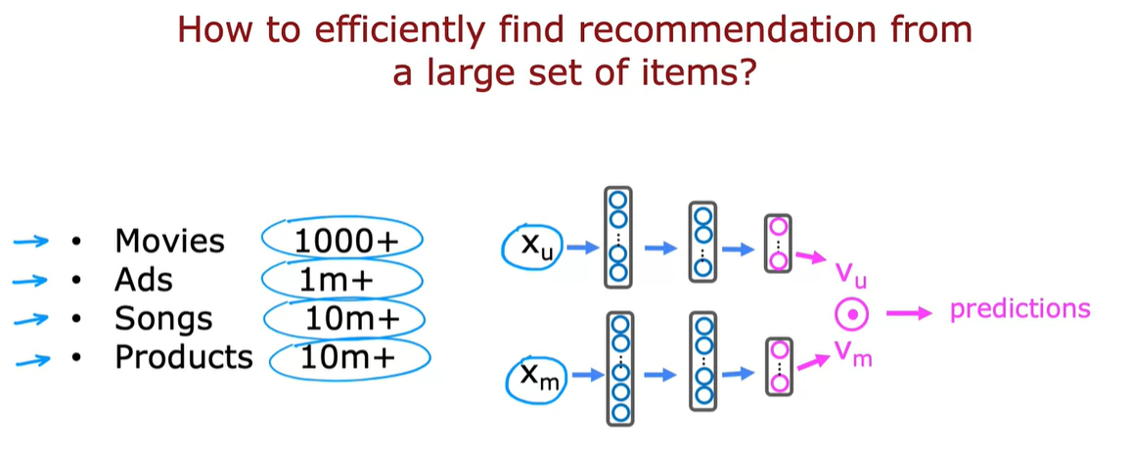

Today's recommended systems will sometimes need to pick a handful of items to

recommend.

From a catalog of thousands or millions or 10s of millions or even more items.

How do you do this efficiently computationally, let's take a look.

Here's in your network we've been

using to make predictions about how a user might rate an item.

Today a large movie streaming site may have thousands of movies or

a system that is trying to decide what ad to show.

May have a catalog of millions of ads to choose from.

Or a music streaming sites may have 10s of millions of songs to choose from.

And large online shopping sites can have millions or

even 10s of millions of products to choose from.

When a user shows up on your website, they have some feature Xu.

But if you need to take thousands of millions of items to feed

through this neural network in order to compute in the product.

To figure out which products you should recommend,

then having to run neural network inference.

Thousands of millions of times every time a user shows up on your website

becomes computational e infeasible

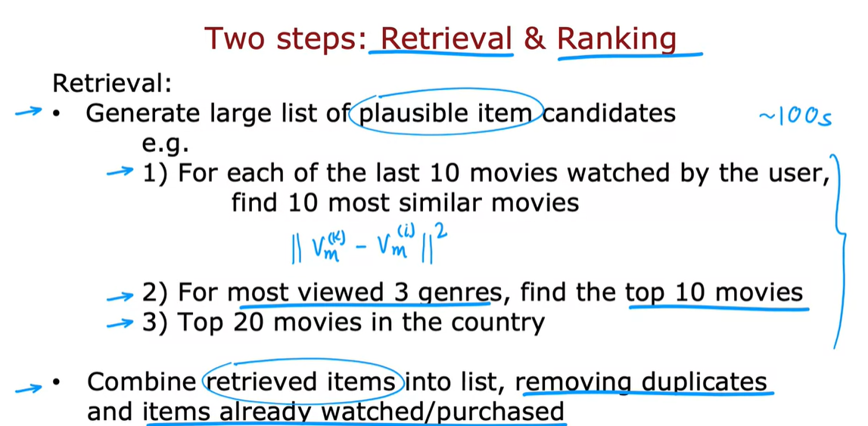

Many law scale recommended systems are implemented as two

steps which are called the retrieval and ranking steps.

The idea is during the retrieval step will generate

a large list of plausible item candidates.

That tries to cover a lot of possible things you might recommend to the user and

it's okay during the retrieval step.

If you include a lot of items that the user is not likely to like and

then during the ranking step will fine tune and

pick the best items to recommend to the user.

So here's an example, during the retrieval step we might do something like.

For each of the last 10 movies that the user has

watched find the 10 most similar movies.

So this means for example if a user has watched

the movie I with vector VIM you can find the movies

hey with vector VKM that is similar to that.

And as you saw in the last video finding the similar movies,

the given movie can be pre computed.

So having pre computed the most similar movies to give a movie,

you can just pull up the results using a look up table.

This would give you an initial set of maybe somewhat plausible movies to

recommend to user that just showed up on your website.

Additionally you might decide to add to it for

whatever are the most viewed three genres of the user.

Say that the user has watched a lot of romance movies and

a lot of comedy movies and a lot of historical dramas.

Then we would add to the list of possible item candidates the top 10

movies in each of these three genres.

And then maybe we will also add to this list the top

20 movies in the country of the user.

So this retrieval step can be done very quickly and

you may end up with a list of 100 or maybe 100s of plausible movies.

To recommend to the user and

hopefully this list will recommend some good options.

But it's also okay if it includes some options that the user won't like at all.

The goal of the retrieval step is to ensure broad coverage to

have enough movies at least have many good ones in there.

Finally, we would then take all the items we retrieve during the retrieval step and

combine them into a list.

Removing two cookers and removing items that the user has already washed or

that the user has already purchased and

that you may not want to recommend to them again.

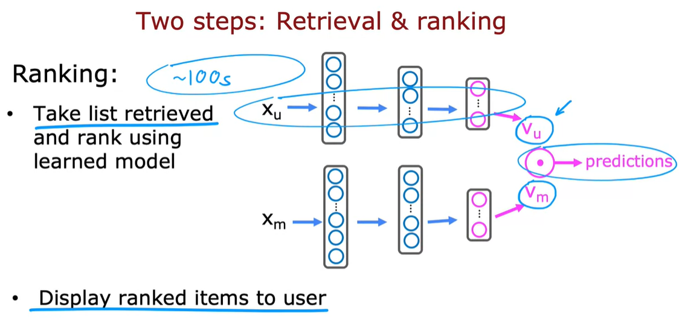

The second step of this is then the ranking step.

During the ranking step you will take the list retrieved during the retrieval step.

So this may be just hundreds of possible movies and

rank them using the learned model.

And what that means is you will feed the user feature vector and

the movie feature actor into this neural network.

And for each of the user movie pairs compute the predicted rating.

And based on this, you now have all of the se 100 plus movies,

the ones that the user is most likely to give a high rating to.

And then you can just display the rank list of items to the user depending on

what you think the user will give.

The highest rating to one additional optimization is that

if you have computed VM.

For all the movies in advance, then all you need to do is to do inference

on this part of the neural network a single time to compute VU.

And then take that VU they just computed for the user on your website right now.

And take the inner product between VU and VM.

For the movies that you have retrieved during the retrieval step.

So this computation can be done relatively quickly.

If the retrieval step just brings up say 100s of movies,

one of the decisions you need to make for

this album is how many items do you want to retrieve during the retrieval step?

To feed into the more accurate ranking step.

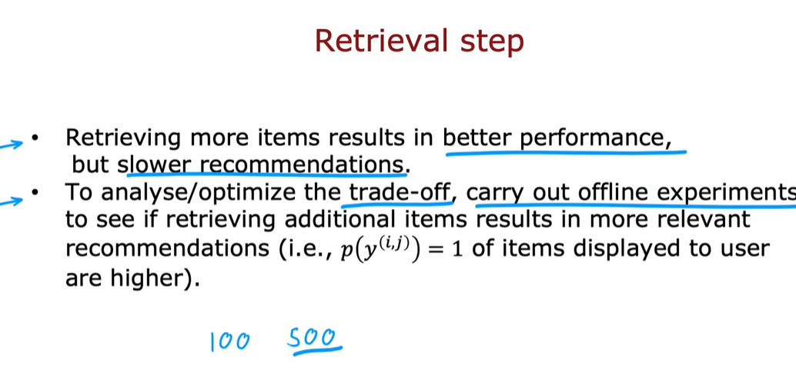

During the retrieval step,

retrieving more items will tend to result in better performance.

But the algorithm will end up being slower to analyze or

to optimize the trade off between how many items to retrieve

to retrieve 100 or 500 or 1000 items.

I would recommend carrying out offline experiments to see how much retrieving

additional items results in more relevant recommendations.

And in particular, if the estimated probability that YIJ.

Is equal to one according to your neural network model.

Or if the estimated rating of Y being high of the retrieve items

according to your model's prediction ends up being much higher.

If only you were to retrieve say 500 items instead of only 100 items,

then that would argue for maybe retrieving more items.

Even if it slows down the album a bit.

But with the separate retrieval step and the ranking step, this allows

many recommended systems today to give both fast as well as accurate results.

Because the retrieval step tries to prune out a lot of items that are just

not worth doing the more detailed influence and inner product on.

And then the ranking step makes a more careful prediction for

what are the items that the user is actually likely to enjoy so that's it.

This is how you make your recommended system work efficiently

even on very large catalogs of movies or products or what have you.

Now, it turns out that as commercially important as our recommended systems,

there are some significant ethical issues associated with them as well.

And unfortunately there have been recommended systems that have

created harm.

So as you build your own recommended system,

I hope you take an ethical approach and use it to serve your users.

And society as large as well as yourself and

the company that you might be working for.

Let's take a look at the ethical issues associated with recommended systems in

the next video

# Video : Ethical Use of recommender systems

Even though recommender systems have been very

profitable for some businesses, that happens,

some use cases that have left

people and society at large worse off.

However, you use recommender systems or

for that matter other learning algorithms,

I hope you only do things that make

society at large and people better off.

Let's take a look at some of

the problematic use cases of recommender systems,

as well as ameliorations to

reduce harm or to

increase the amount of good that they can do.

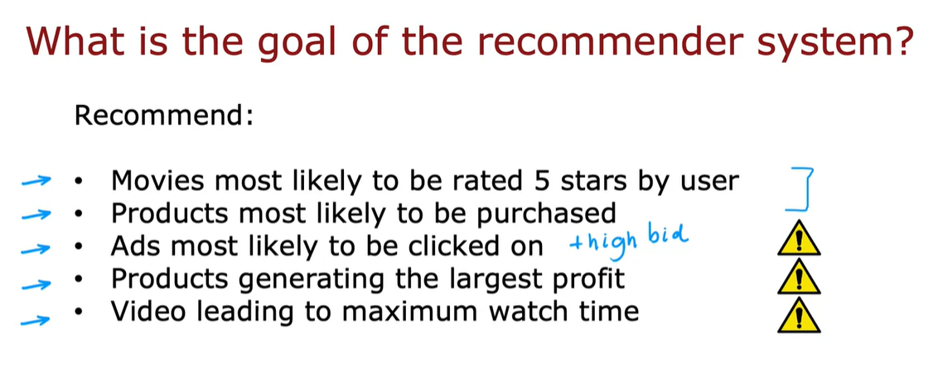

As you've seen in the last few videos,

there are many ways of configuring a recommender system.

When we saw binary labels,

the label y could be,

does a user engage or did they click

or did they explicitly like an item?

When designing a recommender system,

choices in setting the goal of the recommender system

and a lot of choices and

deciding what to recommend to users.

For example, you can decide to recommend to

users movies most likely to be

rated five stars by that user. That seems fine.

That seems like a fine way to show

users movies that they would like.

Or maybe you can recommend to

the user products that they are most likely to purchase.

That seems like a very reasonable use

of a recommender system as well.

Versions of recommender systems can also be

used to decide what ads to show to a user.

One thing you could do is to recommend or really to

show to the user as the most likely to be clicked on.

Actually, what many companies will do

is try to show as likely to click on

and where the advertiser had put in

a high bid because for many ad models,

the revenue that the company

collects depends on whether the ad was

clicked on and what the advertiser had bid per-click.

While this is a profit-maximizing strategy,

there are also some possible negative implications

of this type of advertising.

I'll give a specific example on the next slide.

One other thing that many companies do is

try to recommend products that

generate the largest profit.

If you go to a website and search for a product today,

there are many websites that are not showing you

the most relevant product or the product

that you are most likely to purchase.

But is instead trying to show you

the products that will generate

the largest profit for the company.

If a certain product is more profitable for them,

because they can buy it more

cheaply and sell it at a higher price,

that gets ranked higher in the recommendations.

Now, many companies view a pressure to maximize profit.

This doesn't seem like

an unreasonable thing to do but on the flip side,

from the user perspective,

when a website recommends to you a product,

sometimes it feels it could be nice if

the website was transparent with

you about the criteria

by which it is deciding what to show you.

Is it trying to maximize their profits or

trying to show you things that are most useful to you?

On video websites or social media websites,

a recommender system can also be modified to try to show

you the content that leads to the maximum watch time.

Specifically, websites that are

an ad revenue tend to have

an incentive to keep you on the website for a long time.

Trying to maximize the time you

spend on the site is one way for

the site to try to get more of

your time so they can show you more ads.

Recommender systems today are used to try to maximize

user engagement or to maximize the amount of

time that someone spends on a site or a specific app.

Whereas the first two of these seem quite innocuous,

the third, fourth, and fifth,

they may be just fine.

They may not cause any harm at all.

Or they could also be

problematic use cases for recommender systems.

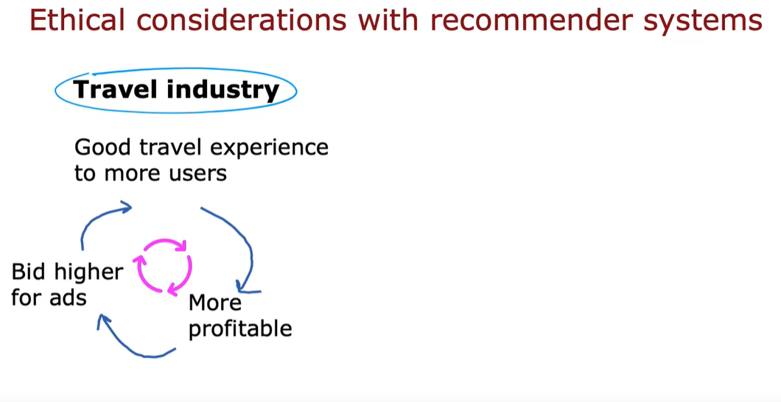

Let's take a deeper look at some of

these potentially problematic use cases.

Let me start with the advertising example.

It turns out that the advertising

industry can sometimes be

an amplifier of some of the most harmful businesses.

They can also be an amplifier of some of the

best and the most fruitful businesses.

Let me illustrate with a good example and a bad example.

Take the travel industry.

I think in the travel industry,

the way to succeed is to try to

give good travel experiences to users,

to really try to serve users.

Now it turns out that if there's

a really good travel company,

they can sell you a trip to

fantastic destinations and make

sure you and your friends and family have a lot of fun.

Then a good travel business,

I think will often end up being more profitable.

The other business is more profitable.

They can then bid higher for ads.

It can afford to pay more to get users.

Because it can afford to bid higher for ads

an online advertising site will show

its ads more often and drive

more users to this good company.

This is a virtuous cycle

where the more users you serve well,

the more profitable the business,

and the more you can bid more for

ads and the more traffic you get and so on.

Just virtuous circle will maybe even tend to hope

the good travel companies

do even better statistically example.

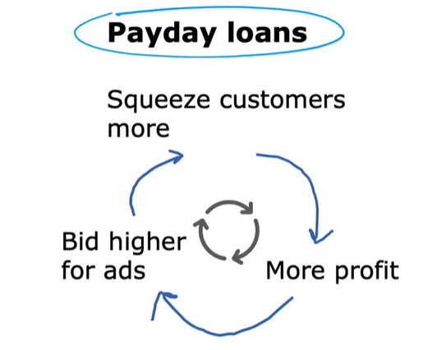



Let's look at the problematic example.

The payday loan industry tends

to charge extremely high-interest rates,

often to low-income individuals.

One of the ways to do well in

the payday loan business is to be really

efficient as squeezing customers

for every single dollar you can get out of them.

If there's a payday loan company

that is very good at exploiting customers,

really squeezing customers for every single dollar,

then that company will be more profitable.

Thus they can be higher for ads.

Because they can get bid higher for ads

they will get more traffic sent to them.

This allows them to squeeze

even more customers and

explore even more people for profit.

This in turn, also increase a positive feedback loop.

Also, a positive feedback loop

that can cause the most exploitative,

the most harmful payday loan companies

to get sent more traffic.

This seems like the opposite effect

than what we think would be good for society.

I don't know that there's an easy solution to this.

These are very difficult problems

that recommend the system's phase.

One amelioration might be to

refuse to set ads from exploitative businesses.

Of course, that's easy to say.

But how do you define what is

an exploitative business and what is not,

is a very difficult question.

But as we build

recommender systems for advertising or for other things,

I think these are questions that each one

of us working on these technologies

should ask ourselves so that we

can hopefully invite open discussion and debate,

get multiple opinions from multiple people,

and try to come up with design choices that allows

our systems to try to do much

more good than potential harm.

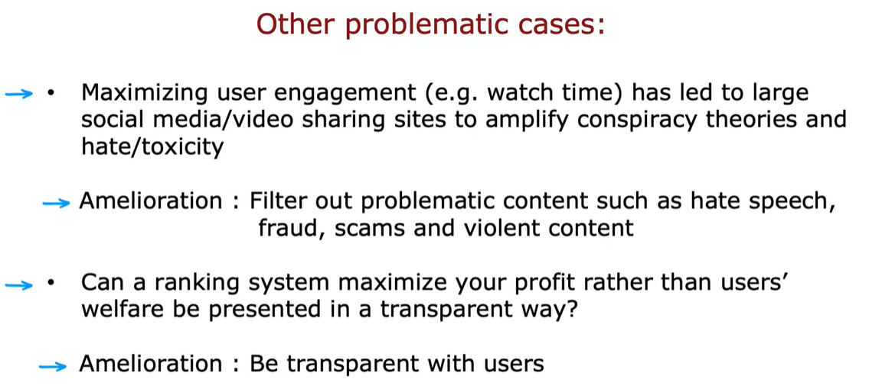

Let's look at some other examples.

It's been widely reported in the news that

maximizing user engagement such as

the amount of time that

someone watches videos on a website

or the amount of time someone spends on social media.

This has led to large social media

and video sharing sites to

amplify conspiracy theories or hate and toxicity

because conspiracy theories and certain types of

hate toxic content is highly

engaging and causes people to spend a lot of time on it.

Even if the effect of

amplifying conspiracy theories amplify

hidden toxicity turns out to be

harmful to individuals and to society at large.

One amelioration for this partial and imperfect

is to try to filter out

problematic contents such as hate speech,

fraud, scams, maybe certain types the violent content.

Again, the definitions of what exactly we should filter

out is surprisingly tricky to develop.

Entices a set of problems that I think

companies and individuals and

even governments have to continue to wrestle with.

Just one last example.

When a user goes to many absolute websites,

I think users think the Apple website

I tried to recommend to

the user thinks that they will like.

I think many users don't

realize that many apps and websites are trying to

maximize their profit rather than necessarily

the user's enjoyment of

the media items that are being recommended.

I would encourage you and

other companies if at all possible,

to be transparent with users about

a criteria by which you're

deciding what to recommend to them.

I know this isn't always easy, but ultimately,

I hope that being more

transparent with users about why we're

showing them and why will increase trust and

also cause our systems to do more good for society.

Recommender systems are very powerful technology,

a very profitable, a very lucrative technology.

There are also some problematic use cases.

If you are building one of these systems using

recommender technology or

really any other machine learning or other technology.

I hope you think through

not just the benefits you can create,

but also the possible harm and

invite diverse perspectives and discuss and debate.

Please only build things and do things that

you really believe can be society better off.

I hope that collectively,

all of us in the eye can only do work that makes

people better off. Thanks for listening.

We have just one more video to go in

recommender systems in which we take a look at

some practical tips for how to implement

a content-based filtering algorithm in TensorFlow.

Let's go on to that last video on recommender systems.

# Video : Tensoflow implementation of content-based filtering

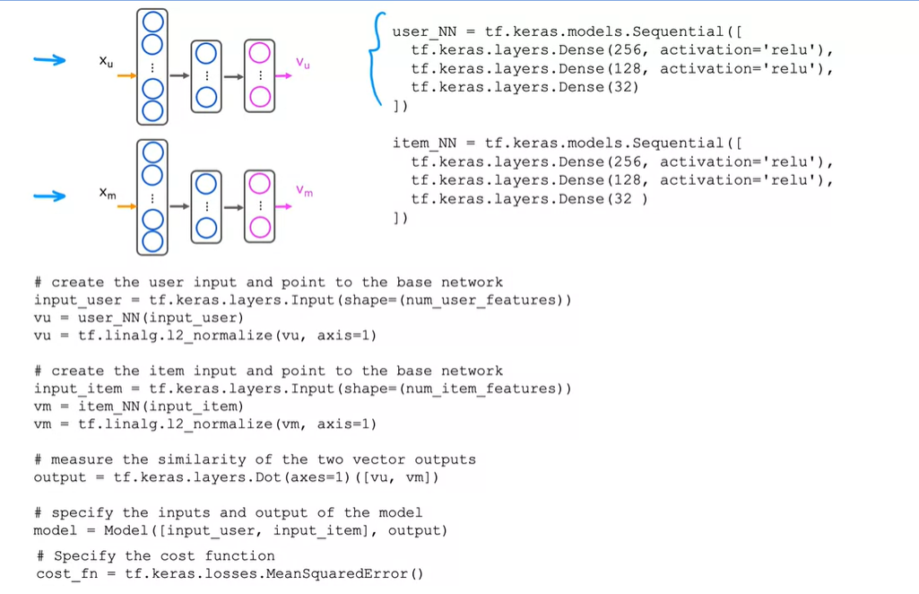

In the practice lab, you see how to implement

content-based filtering in TensorFlow.

What I'd like to do in this video

is just set through of you a few of

the key concepts in the code

that you get to play with. Let's take a look.

Recall that our code has started with

a user network as well as a movie that's work.

The way you can implement this in TensorFlow is,

it's very similar to how we have previously

implemented a neural network with a set of dense layers.

We're going to use a sequential model.

We then in this example have

two dense layers with

the number of hidden units specified here,

and the final layer has 32 units and output's 32 numbers.

Then for the movie network,

I'm going to call it the item network,

because the movies are the items here,

this is what the code looks like.

Once again, we have coupled dense hidden layers,

followed by this layer,

which outputs 32 numbers.

For the hidden layers, we'll use

our default choice of activation function,

which is the relu activation function.

Next, we need to tell

TensorFlow Keras how to

feed the user features or the item features,

that is the movie features to the two neural networks.

This is the syntax for doing so.

That extracts out the input features for

the user and then feeds it to the user

and that we had defined up here to compute vu,

the vector for the user.

Then one additional step that turns out to make

this algorithm work a bit better is at this line here,

which normalizes the vector vu to have length one.

This normalizes the length,

also called the l2 norm,

but basically the length of

the vector vu to be equal to one.

Then we do the same thing for the item network,

for the movie network.

This extract out the item features and feeds it to

the item neural network that we defined up there

This computes the movie vector vm.

Then finally, the step also

normalizes that vector to have length one.

After having computed vu and vm,

we then have to take

the dot product between these two vectors.

This is the syntax for doing so.

Keras has a special layer type,

notice we had here tf keras layers dense,

here this is tf keras layers dot.

It turns out that there's a special Keras layer,

they just takes a dot product between two numbers.

We're going to use that to take

the dot product between the vectors vu and vm.

This gives the output of the neural network.

This gives the final prediction.

Finally, to tell keras

what are the inputs and outputs of the model,

this line tells it that

the overall model is a model with inputs

being the user features and

the movie or the item features and the output,

this is output that we just defined up above.

The cost function that we'll use to train this model

is going to be the mean squared error cost function.

These are the key code snippets for

implementing content-based filtering as a neural network.

You see the rest of the code in

the practice lab but

hopefully you'll be able to play with

that and see how all these code snippets fit together

into working TensorFlow implementation

of a content-based filtering algorithm.

It turns out that there's

one other step that I didn't talk about previously,

but if you do this,

which is normalize the length of the vector vu,

that makes the algorithm work a bit better.

TensorFlows has this l2 normalized motion

that normalizes the vector,

is also called normalizing the l2 norm of the vector,

hence the name of the function.

That's it. Thanks for sticking with me through

all this material on recommender systems,

it is an exciting technology.

I hope you enjoy playing with

these ideas and codes in the practice labs for this week.

That takes us to the lots of

these videos on recommender systems and to

the end of the next to

final week for this specialization.

I look forward to seeing you next week as well.

We'll talk about the exciting technology

of reinforcement learning.

Hope you have fun with the quizzes and with

the practice labs and I

look forward to seeing you next week.